**A**

**Project Report**

**On**

**“Hospital Management System”**

**SMBT HOSPITAL**

**(SANGAMNER)**

**SUBMITED BY**

Miss. Namrata Satish Lanjewar

Miss. Sakshi Sunil Korde

Mr. Roshan Pramod Muneshwar

Mr. Shubham Sanjay Sahane

**GUIDE By**

**Snehal Dhane Mam**



**SUBMITTED TO**

**SAVITRIBAI PHULE PUNE UNIVERSITY**

In partial fulfilment of the award of the degree

Of

**MASTERS IN COMPUTER APPLICATION**

**SINHGAD INSTITUTE OF BUSINESS ADMINISTRATION AND RESEARCH**

**KONDHWA, PUNE-411048**

**During Academic Year**

**2021-2022**

**CERTIFICATE OF ORIGINALITY**

This is to certify that the project report entitled **Hospital Management System** Submitted to the Department of Computer Applications, Sinhgad Institute of Business Administration and Research in partial fulfillment of the requirement for the award of the degree of MASTER OF COMPUTER APPLICATIONS (MCA Affiliated to Savitribai Phule Pune University), is an original work carried out by

Ms. Sakshi Sunil Korde

Ms. Namrata Satish Lanjewar

Mr. Roshan Pramod Muneshwar

Mr. Shubham Sanjay Sahane

Exam No: 56

Exam No: 58

Exam No: 102

Exam No: 106

Under my guidance.

The matter embodied in this project is a genuine work done by the student and has not been submitted whether to this Organization or to any other University/ Organization for the fulfillment of the requirement of any course of study.

Name of the Student :

1. Sakshi Sunil Korde
2. Namrata Satish Lanjewar
3. Roshan Pramod Muneshwar

Signature of the student :

1. Shubham Sanjay Sahane

Signature of the Guide :

Name and Designation of the Guide : **Snehal Dhane Mam**

Signature of Director-MCA

**Dr. Netra Patil**  :

Date :

**CERTIFICATE OF APPROVAL**

This is to certify that the project report entitled **Hospital Management System** submitted to the Department of Computer Application, Sinhgad Institute of Business Administration and Research in partial fulfillment of the requirement for the award of the Degree of MASTER OF COMPUTER APPLICATIONS (MCA Affiliated to Savitribai Phule Pune University) is an original work carried out by

Ms. Sakshi Sunil Korde

Ms. Namrata Satish Lanjewar

Mr. Roshan Pramod Muneshwar

Mr. Shubham Sanjay Sahane

Exam No: 56

Exam No: 58

Exam No: 102

Exam No: 10

The matter embodied in this project is a genuine work done by the student and has been certified by the following internal and external examiners deputed by Savitribai Phule Pune University.

Internal Examiner External Examiner

**INDEX**

**CHAPTER 1 : INTRODUCTION**

1.1 Company Profile

1.2 Introduction

1.3 Existing System and Need for System

1.4 Limitations of existing system

**CHAPTER 2 : PROPOSED SYSTEM**

2.1 Problem statement/s

2.2 Product position statement

2.3 Product overview

2.4 Summary of capabilities

2.5 Assumptions and dependencies

2.6 Objectives of proposed system

2.7 Functional requirements

2.8 Nonfunctional requirements

2.9 Stakeholder summary

2.10 Users summary

2.11 Scope of the system

2.12 Module specifications

2.13 Operating environment

**CHAPTER 3 : REQUIREMENT DETERMINATION AND ANALYSIS**

3.1 Fact finding methods

3.2 Feasibility study

**CHAPTER 4 : SYSTEM ANALYSIS & DESIGN**

4.1 Use Case Diagrams

4.2 Sequence Diagram

4.3 Activity Diagram ERD

4.4 Class Diagram

4.5 Object Diagram

4.6 Module Hierarchy Diagram

4.7 Component Diagram

4.8 Deployment Diagram ( in case of Web Deployment )

4.9 Module Specifications

4.10 Interface Diagram ( in case of WAP and Embedded Systems )

4.11 Web Site Map Diagram in case of Web Site )

4.12 User Interface Design (Screens etc.)

4.13 Table specifications (in case back end is a database)

4.14 Test Procedures and Implementation

**CHAPTER 5 : USER MANUAL**

5.1 Drawbacks and Limitations

5.2 Proposed Enhancements

5.3 Conclusion

5.4 Bibliography

ANNEXURES:

ANNEXURE 1 : USER INTERFACE SCREENS

ANNEXURE 2 : SAMPLE PROGRAM CODE / Project Demo( which will prove sufficient development is done by the student )

**CHAPTER 1**

**1.1 INTRODUCTION:-**

The project Hospital Management system includes registration of patients, storing their detailsinto the system, and also computerized billing in the pharmacy, and labs. The software has thefacility to give a unique id for every patient and stores the details of every patient and the staffautomatically. It includes a search facility to know the current status of each room. User cansearch availability of a doctor and the details of a patient using the id.The Hospital Management System can be entered using a username and password. It isaccessible either by an administrator or receptionist. Only they can add data into the database.The data can be retrieved easily. The interface is very user-friendly. The data are well protectedfor personal use and makes the data processing very fastHospital Management System is powerful, flexible, and easy to use and is designed anddeveloped to deliver real conceivable benefits to hospitals.Hospital Management System is designed for multispeciality hospitals, to cover a wide range ofhospital administration and management processes. It is an integrated end-to-end HospitalManagement System that provides relevant information across the hospital to support effectivedecision making for patient care, hospital administration and critical financial accounting, inflow.Hospital Management System is a software product suite designed to improve the quality andmanagement of hospital management in the areas of clinical process analysis and activity-basedcosting. Hospital Management System enables you to develop your organization and improve its effectiveness.

**1.2EXISTING SYSTEM:-**

* The current manual system has a lot of paper work. To maintain the records of sale and service manually, is a Time-consuming task.
* With the increase in database, it will become a massive task to maintain the database.
* Requires large quantities of file cabinets, which are huge and require quite a bit of space in the office, which can be used for storing records of previous details.
* The retrieval of records of previously registered patients will be a tedious task.
* Lack of security for the records, anyone disarrange the records of your system.
* If someone want to check the details of the available doctors the previous system does not provide any necessary detail of this type.
* To find out about the patient’s history, the user has to go through various registers.
* The information generated by various transactions takes time and efforts to be stored at right place.
* Various changes to information like patient details or immunization details of child are difficult to make as paper work is involved.
* Manual calculations are error prone and take a lot of time this may result in incorrect information. For example calculation of patient’s bill based on various treatments.

**1.3 Need for System**

Our present modern information system makes use of computers for the execution, each of them connected through an optimized network. Healthcare is the most critical aspect of our society, and many health care providers face challenges to offer practical and active services to patients.

Considering a multispeciality hospital, many people enter and exit the hospital in a day and maintaining their records safely is tedious. To reduce this type of burdens and to manage the financial, hospital administration and clinical aspects, Hospital management system came into existence.

Apart from that automating your hospital's processes and implementing them cannot be done too easily, you need an efficient hospital management system to take care of everything that is happening around the labs and hospitals.

If you are ready to implement or go with the hospital management system, make sure you follow these things before making it useful in your hospitals or labs.

Processing Speed & Results

Cost Effective

Reduction in Errors

Data Security & Retrieving Ability

Improved Patient Care

Quality & Compliance

**1.4 Limitations of existing system**

* + - Lack of security of data.
    - Time Consuming.
    - Consumes large Volume of Paper work.
    - Manual Work.
    - No direct role for higher Official.

To Avoid all these limitations and make the system working more accurately it needs to be Computerized.

**CHAPTER 2**

**2.1 PROPOSED SYSTEM :-**

Our Hospital Management System is designed for SMBT Hospital to replace their existing manual paper based system To the Digital System. The new system is to control the information of patients With theirs Medical History. Room availability, staff and operating room schedules and patient invoices These services are to be provided in an efficient, cost effective manner, with the goal of reducing the time and resources currently required for such tasks. Also Patient can take appointment from home and access their information worldwide .Various Patients reports like blood test’s , MRI , CT scan ,X-ray directly added into Patients Records it reduces Time for pick up reports and take them to doctor . Medicine allergie are highlighted Before prescribing any drugs .

**2.2 Problem Statement**

Since Hospital is associated with the lives of common people and their day-to-day routines so I decided to work on this project. The manual handling of the record is time consuming and highly prone to error. The purpose of this project is to automate or make online, the process of day-to-day activities like Room activities ,Admission of New Patient, Discharge of Patient, Assign a Doctor, and finally compute the bill etc. I have tried my best to make the complicated process Hospital Management System as simple as possible using Structured & Modular technique & Menu oriented interface. I have tried to design the software in such a way that user may not have any difficulty in using this package & further expansion is possible without much effort. Even though I cannot claim that this work to be entirely exhaustive, the main purpose of my exercise is perform each Hospital’s activity in computerized way rather than manually which is time consuming.

**2.3 Product overview**

The Hospital Management System (HMS) is designed for Any Hospital to replace their existing manual, paper based system. The new system is to control the following information; patient information, room availability, staff and operating room schedules, and patient invoices. These services are to be provided in an efficient, cost effective manner, with the goal of reducing the time and resources currently required for such tasks.

A significant part of the operation of any hospital involves the acquisition, management and timely retrieval of great volumes of information. This information typically involves; patient personal information and medical history, staff information, room and ward scheduling, staff scheduling, operating theater scheduling and various facilities waiting lists. All of this information must be managed in an efficient and cost wise fashion so that an institution's resources may be effectively utilized HMS will automate the management of the hospital making it more efficient and error free. It aims at standardizing data, consolidating data ensuring data integrity and reducing inconsistencies.

**2.4 Objective of Proposed System**

Main objectives of a Hospital Management System are:

* Design a system for better patient care.
* Reduce hospital operating costs.
* Provide MIS (Management Information System) report on demand to management for better decision making.
* Better co-ordination among the different departments.
* Provide top management a single point of control.

Hospital management System handles activities of major departments in a hospital like:

1.Front Office/OPD Management

2. Patient management (scheduling, registration and long-term care)

3. Patient care management and departmental modules (radiology, pharmacy and pathology labs)

4. Investigative Labs

5. Bill View

6. Medical Stores

7. Financial Accounting (billing, insurance processing, materials management, accounts payable/receivable, payroll and general ledger)

Hospital management system can be developed by using waterfall model which is a popular version of development life cycle model for software engineering. It describes a development method that is linear and sequential. It has distinct goals for each phase of development. In this model once, a phase of development is completed, there is no turning back, the development proceeds to the next phase. The advantage of this model is that it allows for departmentalization and managerial control.

**2.5 Functional Requirements**

There are a lot of software requirements specifications included in the functional requirements of the Hospital Management System, which contains various process, namely Registration, Check out, Report Generation, and Database.

**Registration Process of SRS (Software Requirements Specification)**

● Adding Patients: The Hospital Management enables the staff in the front desk to include new patients to the system.

● Assigning an ID to the patients: The HMS enables the staff in the front desk to provide a unique ID for each patient and then add them to the record sheet of the patient. The patients can utilize the ID throughout their hospital stay.

**Check Out of SRS:**

● Deleting Patient ID: The staff in the administration section of the ward can delete the patient ID from the system when the patient's checkout from the hospital.

● Adding to beds available list: The Staff in the administration section of the ward can put the bed empty in the list of beds-available.

**Report Generation of SRS:**

● Information of the Patient: The Hospital Management System generates a report on every patient regarding various information like patients name, Phone number, bed number, the doctor's name whom its assigns, ward name, and more.

● Availability of the Bed: The Hospital Management system also helps in generating reports on the availability of the bed regarding the information like bed number unoccupied or occupied, ward name, and more.

**Database of SRS:**

● Mandatory Patient Information: Every patient has some necessary data like phone number, their first and last name, personal health number, postal code, address, city, 'patient's ID number, etc.

● Updating information of the Patient: The hospital management system enables users to update the information of the patient as described in the mandatory information included.

**2.6 Non Functional Requirements**

There are a lot of software requirements specifications included in the non-functional requirements of the Hospital Management System, which contains various process, namely Security, Performance, Maintainability, and Reliability.

**Security:**

● Patient Identification: The system needs the patient to recognize herself or himself using the phone.

● Logon ID: Any users who make use of the system need to hold a Logon ID and password.

● Modifications: Any modifications like insert, delete, update, etc. for the database can be synchronized quickly and executed only by the ward administrator.

● Front Desk Staff Rights: The staff in the front desk can view any data in the Hospital Management system, add new patients record to the HMS but they don't have any rights alter any data in it.

● Administrator rights: The administrator can view as well as alter any information in the Hospital Management System.

**Performance:**

● Response Time: The system provides acknowledgment in just one second once the 'patient's information is checked.

● Capacity: The system needs to support at least 1000 people at once.

● User-Interface: The user interface acknowledges within five seconds.

● Conformity: The system needs to ensure that the guidelines of the Microsoft accessibilities are followed.

**Maintainability:**

● Back-Up: The system offers the efficiency for data back up.

● Errors: The system will track every mistake as well as keep a log of it.

**Reliability:**

● Availability: The system is available all the time.

Hope you got a clear idea on the functional and non-functional requirements and the features required by the hospital. Any other queries on the topic are welcome.

**2.7 SCOPE OF THE SYSTEM**

Hospitals and healthcare centers have undergone a change for its betterment. The administrations of healthcare sector are opting IT solutions for the better management and patient care in their hospital campus.

* Patient can book appointments with doctors from home So They don’t have to wait for checkups
* Doctor Can Instantly Access Patients Medical History To avoid situations like medicine allergy .
* Patient can check Doctors Availability in case of Specialist Visit in Hospital .
* Patients can easily Book his/her Appointment by entering name, contact number ,age and gender. Whenever the Patient comes up his information is stored freshly.
* Bills are generated by recording price for each facility provided to Patient on a separate sheet and at last they all are summed up.
* Diagnosis information of patients is Stored In System So Wheneverpatientcomes for checkup Doctors Can Easilyaccess that information .
* Immunization records of children are maintained in pre-formatted sheets, which are kept in a file.
* Information about various diseases is not kept as any document. Doctors themselves do this job by remembering various medicines.
* Daily functions like patient registration, monitoring blood bank, managing admission and overall management of various departments can be easily performed with higher accuracy after the installation of [hospital software](http://www.hospitalerpsoftware.in/).
* The modules of hospital management software are user-friendly and easy to access. It has a common user friendly interface having several modules. The officials can utilize these modules in their processes without any hassle and make the best possible use of system.
* This tool is a comprehensive solution that integrates all the departments by creating a common platform. In brief, hospital management system has all the modules that serve purpose of all the
* departments of healthcare institute. In fact, these modules have been competitively designed to make all the operations simplified.
* Blood Reports from Laboratory  can quickly uploaded in a system so Doctors can Directly Access it While Treating patients .
* Availability of blood according to blood-group of the patients can easily Verify as per requirement.
* Emergency Staff Will Inform Before patient reaches the hospital in case of accidental or other emergency for the Medication.
* Other Medical Services From hospital like MRI,X-Ray,CT Scan can attach their reports directly to patients Record .
* Covid vaccine availability can be checked from home.

All this work is done manually by the receptionist and other operational staff and lot of papers are needed to be handled and taken care of. Doctors have to remember various medicines available for diagnosis and sometimes miss better alternatives as they can’t remember them at that time.

**2.8 MODULES SPECIFICATIONS**

1. **Admin :**

* Manage department of hospitals, user, doctor, nurse, pharmacist, laboratorist and other staff Accounts.
* Watch appointment of doctors.
* Watch transaction reports of patient payment.
* Bed ,ward,ICU status.
* Watch blood bank report.
* Watch operation and diagnosis report.
* Watch birth report.

1. **Patient :**

* View appointment list and status with doctors and book appointments.
* View prescription details And medication from doctor.
* View doctor list And Availability.
* Manage Medical History’s.
* View Admit history like bed, ward icu etc..
* Manage own profile.

1. **Appointment :**

* Show Schedule Appointment’s to the doctors.
* Manages the patient appointment like Book ,Cancel ,Update.
* Provide accurate schedule for booking appointments for avoiding crowd.

1. **Casebook :** In Medical history contains following data.

* Includes all diseases and illnesses currently being treated, and those which have had any residual effects on the patient's health.
* Surgical history to include all invasive procedures the patient has undergone.
* Family history for genetic predisposition to disease.
* Social history include patients smoking or other tobacco use, alcohol and drug history.
* Also include other aspects like patient's health including spiritual, mental, relationship status, occupation, hobbies, and sexual activity or pertinent sexual habits.
* Other data in case of acute and chronic disease state.
* Patient allergies to clarify the reaction they had to the medication.
* Medication history as patients take more and more medications and drug-drug interactions must be avoided.
* Data about new born which contains complications of the pregnancy, delivery, and prematurity.
* Manages information about the immunization status of the patient.
* In case of female patient's they can provide information about last menstrual period and their pregnancy history to include gravidity and parity should be common practice.

1. **Doctor :**

* Create, manage appointment with patient.
* Create prescription for patient.
* Provide medication for patients.
* View test report’s ,Medical History ,Vaccination.
* Can admit patient and assign specialist doctor.
* Update patients records
* Issue for operation of patients and creates operation report
* Manage own profile.

1. **Wards :**

* Manages patient in different types of wards as follows :

1. ICU
2. Special Room
3. Semi Private
4. General Ward
5. **Nurse :**

* Update Admitted patient’s records.
* Assist Doctors.
* anage patient.
* Allot bed, ward, cabin for patients.
* Provide medication according to patient prescription.
* Manage blood bank and update status.
* Keep record of patient operation, baby born and death of patient.
* Manage own profile.

1. **Pharmacist :**

* Maintain medicine and Keep records of hospitals stock medicines and status.
* Manage medicine categories.
* Watch prescription of patient.
* Provide medication to prescriptions.
* Update medicine to patients records.

1. **Laboratorist :**

* Watch prescription list for performing test’s.
* Upload diagnostic/test report to patient’s record’s.
* Preview of report files like xray images, ct scan, mri reports
* Maintain Blood bank blood availability.
* Manage own profile.

1. **Accountant :**

* Generate Bill according to services used by patient.
* Take cash payment ,and Create invoice for payment.
* Watch payment history of patients.
* Manage own profile.

1. **Immunization :**

* Auto generates schedule for new-born.
* Manage vaccine availability and takes appointment according.
* Show appointments and update status of taken vaccine.
* Update patients record.

1. **Emergency :** An emergency department is a dedicated area in a hospital that is organised and administered to provide a high standard of emergency care to people in the community who perceive the need for, or are in need of, acute or urgent care including hospital admission.

* Sending Ambulance with doctor to the locations.
* Manage Emergency Services.
* Inform OT staff for making priparations and check blood type available.
* Inform specialist and Anaesthetist if require’s .
* Inform ICU staff for making preparations in ICU with equipments.

1. **Organ_Donar :** Organ donation is the process when a person allows an organ of their own to be removed and transplanted to another person, legally, either by consent while the donor is alive or dead with the assent of the next of kin.

* Patient register for organ donation with current and permanent address also with contact details.
* Managing Medical reports of donar with Blood type,Tissue type,Organ size.
* Manages reports of evaluation for donor suitability based on their medical history and age.
* Under legal age patient cannot register for organ donation they only fill donar card.
* View and edit previously register form.
* Manage Organs and tissues that can be transplanted.

**CHAPTER 3**

**REQUIREMENTS DETERMINATION AND ANALYSIS :-**

|  |  |  |  |  |
| --- | --- | --- | --- | --- |
| **Item** | **Web server (minimal)** | **Web server (recommended)** | **Combined Web & Database Server (minimal)** | **Combined Web & Database Server (recommended)** |
| **Processor** | 1.6 GHz CPU | 2 x 1.6 GHz CPU | 2 x 1.6 GHz CPU | 4 x 1.6 GHz CPU |
| **RAM** | 1-1.75 GB | 3-5 GB | 3-5 GB | 7 GB |
| **HDD** | 1x 100 GB of free space or more is recommended for data (non-system drive is preferred) 1x 20 GB of free space is recommended for the software’s (system drive) | | | |
| **Operating System** | Windows* Server, Linux*, or any operating system that can run as a webserver, capable of delivering HTML5 , JavaScript content, including JSON and MP4. | | | |
| **.NET Framework** | Microsoft .NET Framework 4.5 | | | |
| **Software Requirements for Web Servers** | Internet Information Services (IIS) 6, 7.0, 7.5 or 8 ,  Windows PowerShell 2.0, 3.0 or 4.0,  Apache , MySQL | | | |
| **Software Requirements For Users** | Any latest Browser or preceding 2 versions of that Browser. | | | |

**3.1 FEASBILITY STUDY :-**

**Technical Feasibility:**

* The technical feasibility carried out for this system determined whether the planned system could be developed and design in organization using the existing technology.
* The existing system can have expertise to use it. The organization is already equipped with require hardware and software.
* The hardware currently available has enough memory to support software. Hence this system technically feasible.

**Economical Feasibility:**

* While considering the economical feasibility it is checked inn points like performance, information, and output from this system.
* Economic of system at financial experts of project. It determines whether the investment that goes into the implementation of system is recoverable.
* As the hardware and software are already available and no investment are to be made in that direction. Thus system is economical feasible.

**Operational Feasibility:**

* Operational feasibility ends at checking if the system will work in more efficient and accurate manner through all routine operations.
* This system is made to be comprehensive in nature using a full menu driven system & appropriate user informative messages.
* No training is required, User can easily operate the system.
* Our system is user friendly, View of system is very simple that for not trouble for handling user.

**CHAPTER 4**

**4.1 Use Case Diagram**

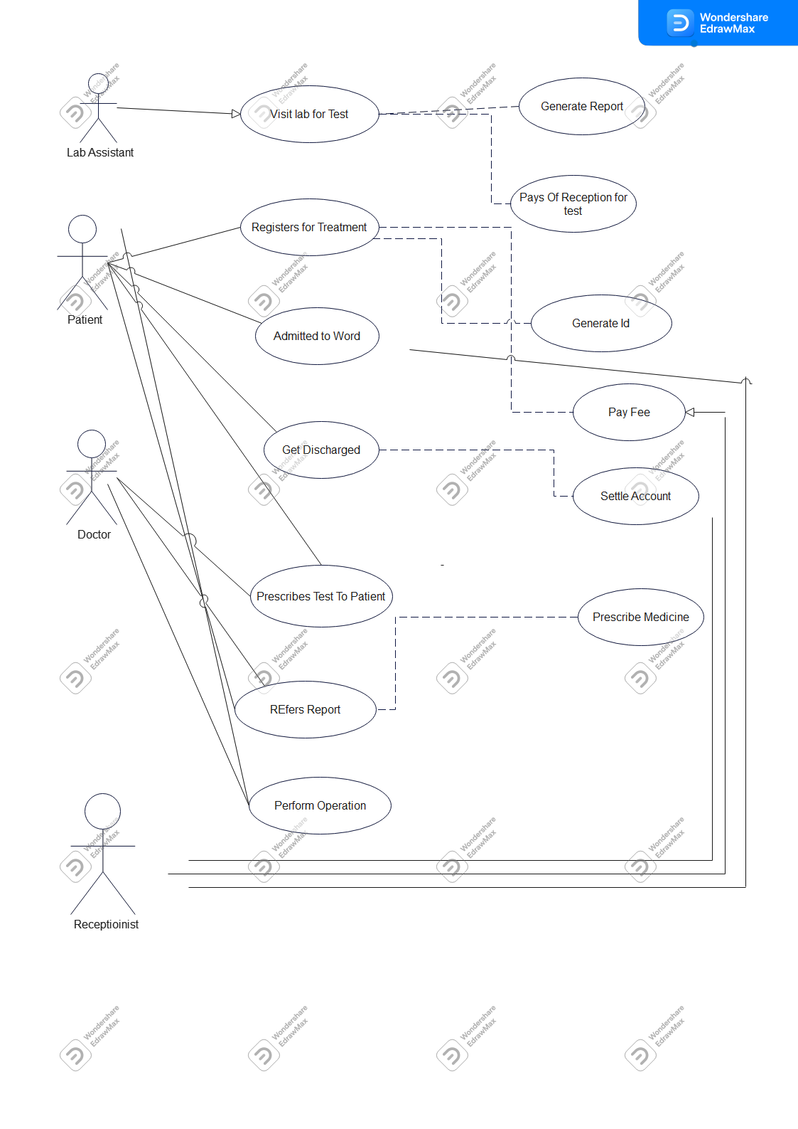

**4.3 Activity Diagram ERD**

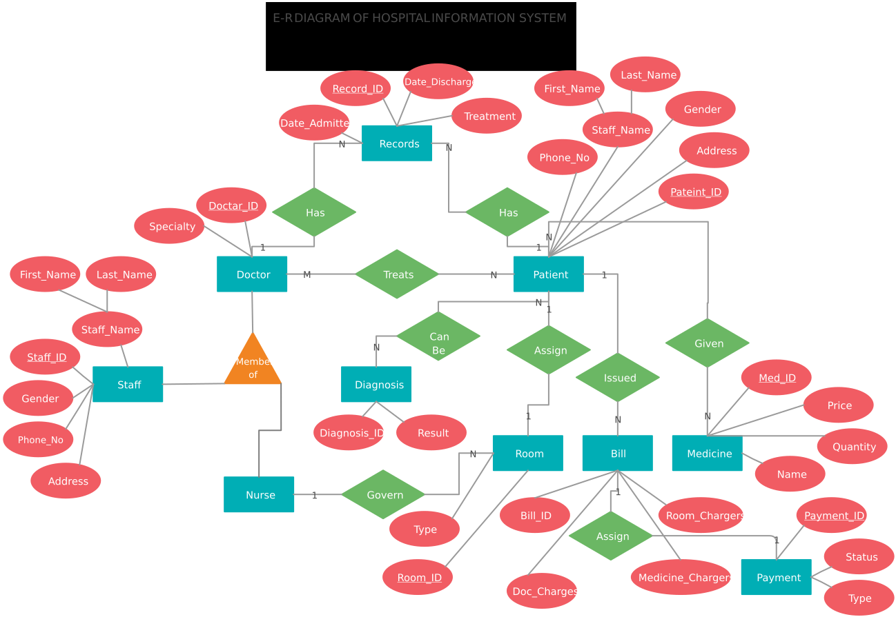

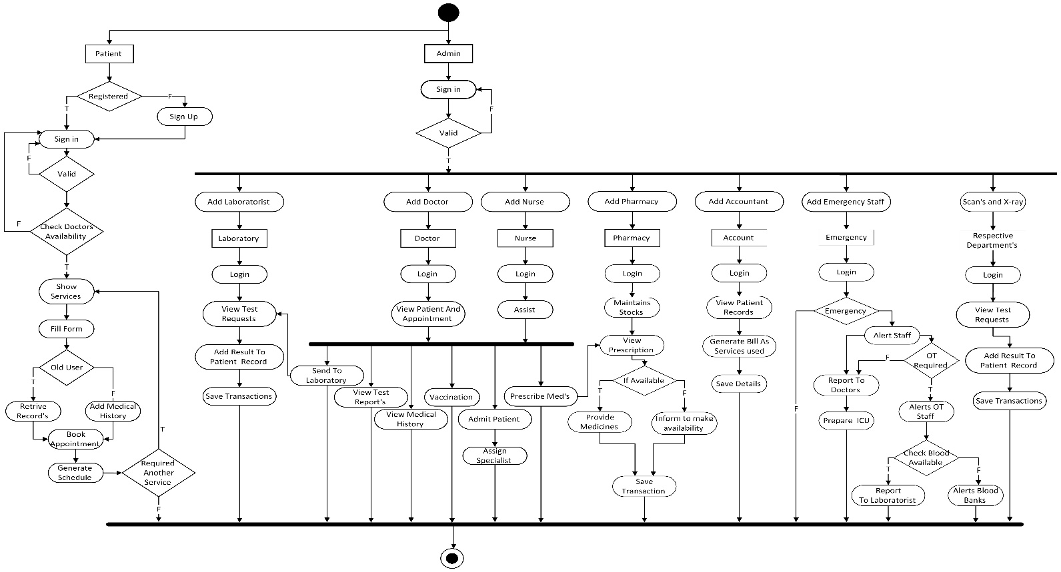

**4.4 Class Diagram**

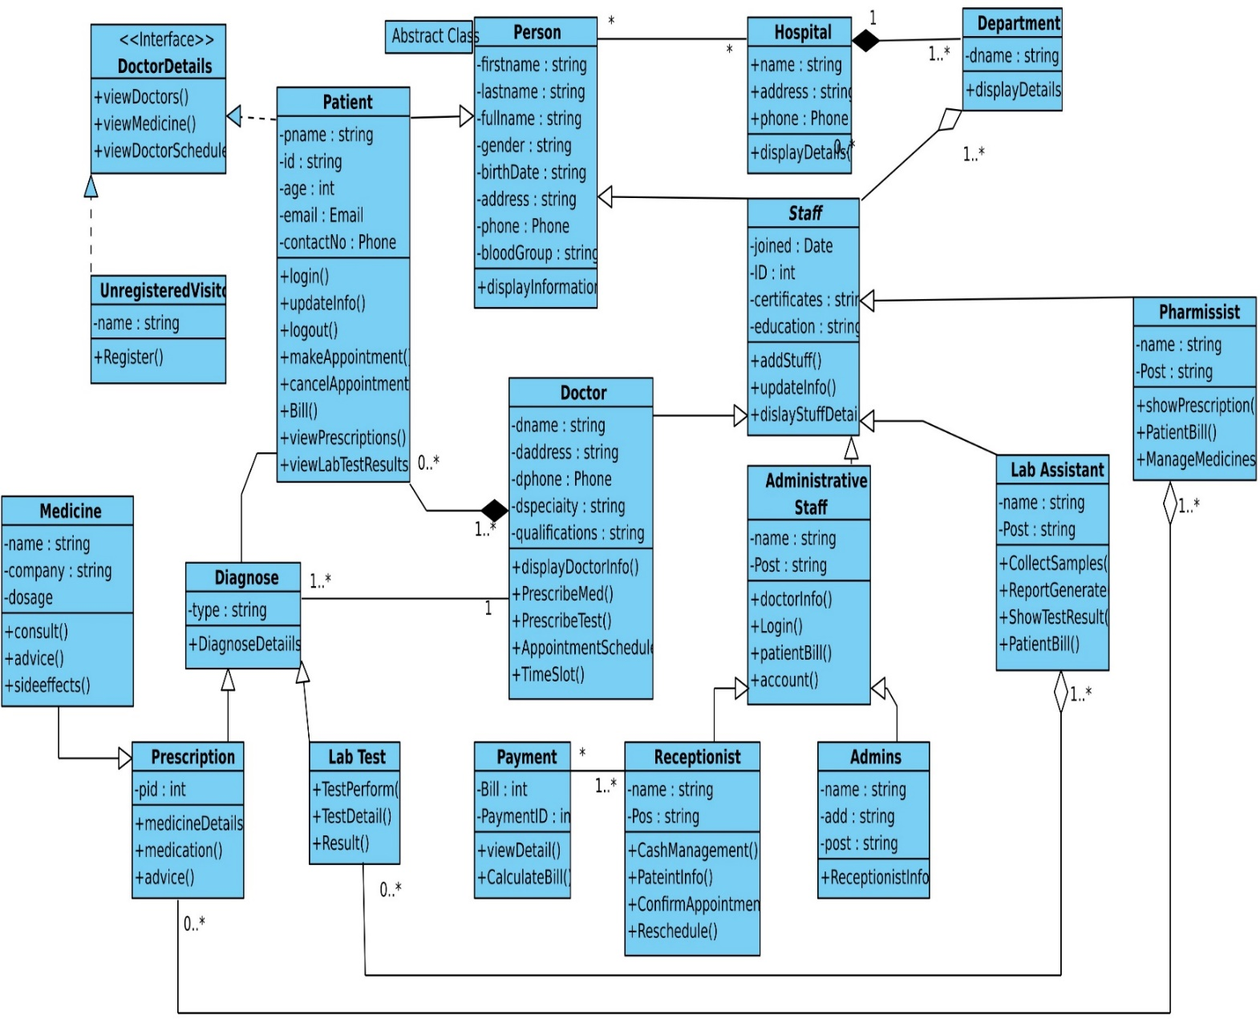

**4.5 Object Diagram**

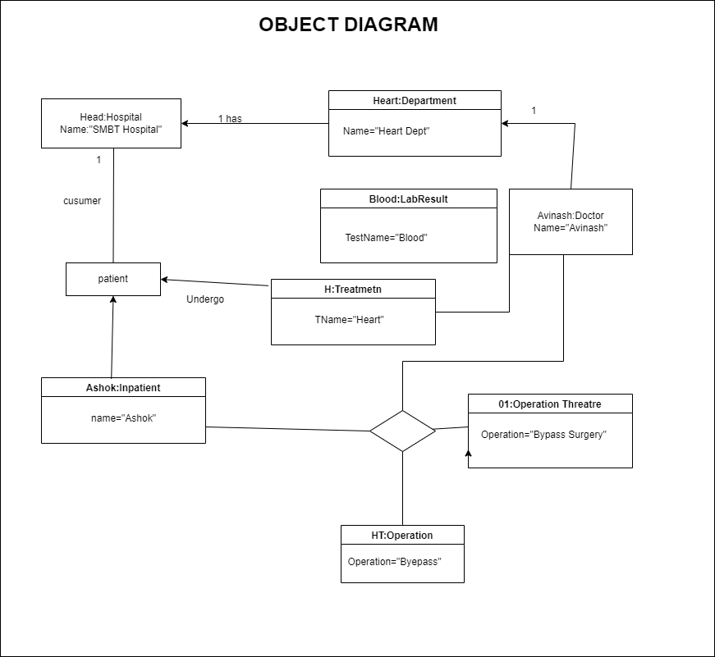

**4.6 Doctor State Chart Diagram**

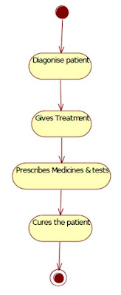

**4.7 Patient State Chart Diagram**

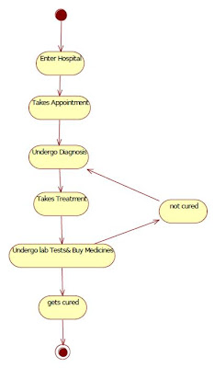

**4.8 Reception State Chart Diagram**

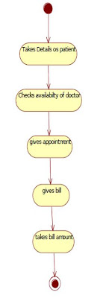

* 1. 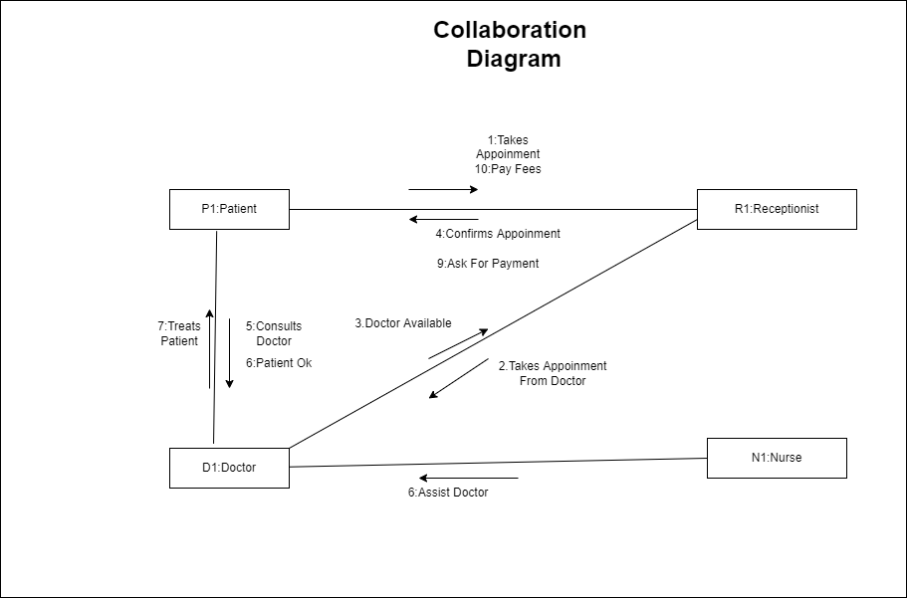**Collaboration Diagram :**

**CHAPTER 5 : User Manual**

**5.1 : Drawbacks and Limitations**

1. Online Payment Not Available
2. Online Consultant Is Under Progress
   1. **Proposed Enhancements**
3. Adding Chat And Video call in app Section For patient and doctors to

Discuss Case

1. Online Payment mode
   1. **Conclusion**

Implementation of hospital management system project helps to store all kinds of record’s provide coordination and user communication , implement policies , improve day-to-day operations, arrange the supply chain,manage finiacial and human resources ,and market hospital services.

* 1. **Bibliography**

***Website :***

* *https://stackoverflow.com/*
* *https://www.javascript.com/learn/*
* *https://dev.mysql.com/doc/*
* *https://www.quora.com/*
* *https://www.javatpoint.com/*
* *https://www.w3schools.com/*
* *https://www.youtube.com/*

***Book’s :***

* *Artiﬁcial Mind System - Kernel Memory Approach - Tetsuya Hoya*
* *Beginning Database Design - Gavin Powell*
* *Agile Java Development With Spring, Hibernate, And Eclipse - Anil Hemrajani*
* *HTML 5 Black Book: Covers CSS3, Javasvript, XML, XHTML, AJAX, PHP and jQuery - Kogent Learning Solutions Inc.*

**ANNEXURES 1: User interface Screen’s**

